**Name:** ______________________________________

**Date:** _________________________________________

**Station 1- Design**

The point of this station is for you to draw / design how you want your website to

look like. Use the next few pages to draw your ideal website for the WOW!

**Station 2: Tag Identification**

Choose two of the screenshots and describe what you see. For example, if you see an image, write out the image tag. If you see that it’s a paragraph and the font is red, describe it and write out the tag and style.

**Screenshot 1**

**Screenshot 2**

**Station 3: Madlibs**

In front of you there should be index cards and a HTML file. The index cards are just there to help you, you may not need it. Fill in the blanks.

1. __________________________________
2. __________________________________
3. __________________________________
4. __________________________________
5. __________________________________
6. __________________________________
7. __________________________________
8. __________________________________
9. __________________________________
10. __________________________________
11. __________________________________
12. __________________________________
13. __________________________________
14. __________________________________
15. __________________________________
16. __________________________________
17. __________________________________
18. __________________________________
19. __________________________________
20. __________________________________
21. __________________________________
22. __________________________________
23. __________________________________
24. __________________________________

**Station 4: Word Search**

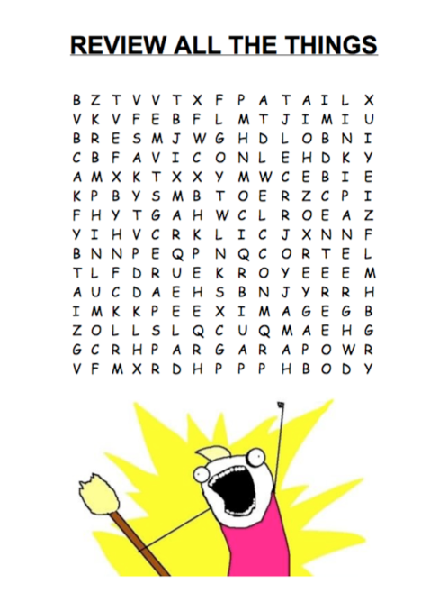

**Station 5: Game**

Station 5 is a little review game on the web. You can access it anytime by going to <http://codeed.heroku.com>. When you finish this station fill in the following information below.

**Name:** ____________________________

**Score:** ____________________________

**Time:** _____________________________

**Station 6: Site Builder**

Here you will build a website. HTML tags are written on index cards. Once complete the site, write down the numbers behind the index cards in order.

**Prize Sheet**

If you complete all the stations you will receive a prize.